Authorization to Proceed
2051 Druid Park
Photos and Materials

General Scope: Construct new rear 3-story addition (625 sf) with ground level patios and 2nd and 3rd story decks (14’x5’). New doors and windows throughout. Addition will be clad with standard hardie board siding and vertical board and batten style siding as per plans.
2051 Druid Park Dr – Narrative
2051 Druid Park Dr is a standalone structure, having about 3’ of setback from neighboring properties. It is 2 stories in front and 3 stories in the rear, as it is set on a sloped grade towards the rear in the Woodberry region. The proposed construction plan includes exterior demo of an existing and dilapidated rear extension. This previously constructed addition is not a contributing historic structure. In its place a 3-story addition (14’ x 44’) with ground level patios, and 2nd and 3rd story decks will be constructed. The addition will include exterior windows, doors (black), deck railings (black), and be clad with Hardie board siding (Gray Cedarmill) on the main portion and board and batten style (Midnight Soot Rustic Grain) to complement along the sides/deck areas. The main historic structure at 2051 Druid Park Dr. will not demolished or altered.
Rationale for the proposed design includes meeting the interior demand for space for the proposed apartment units, including giving these units some exterior living space (patios/decks) as is the case on the existing structure. The front façade has already been redesigned to bring back historic nature. The rear extension, as stated, is in poor condition, and was not part of the original historic structure. The addition will be aesthetically and structurally superior to what it is replacing and comply with all CHAP standards for the rear portion of a historic building.
Most significant historic features of the structure pertained to the front façade facing Druid Park Dr. and were sufficiently restored on a previously approved application. The rear faces the alleyway and does not contain features of note regarding historic significance or value; however, the addition is aimed to represent a tie-in of old with new, using suitable materials to complement each other.

Existing condition:
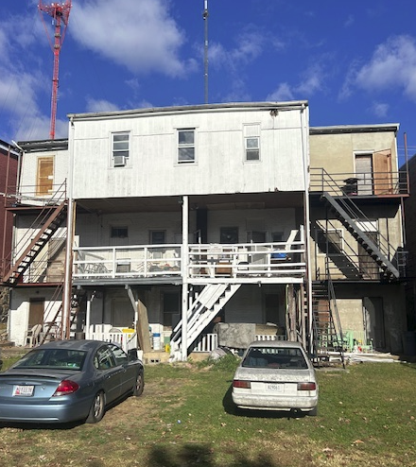
Proposed construction:
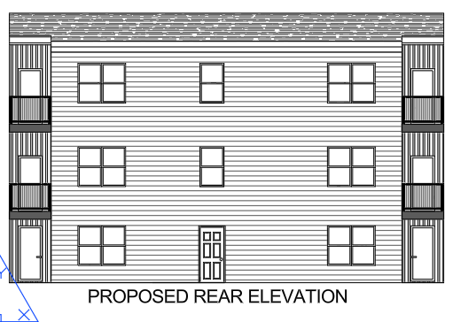

Materials:
Main rear entry door and doors to decks.
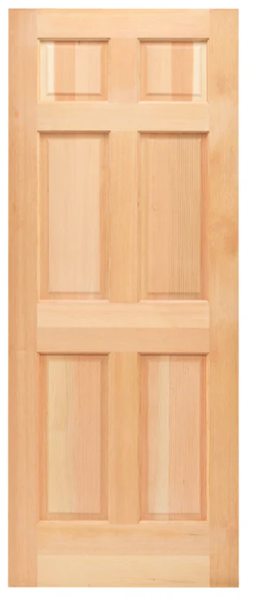
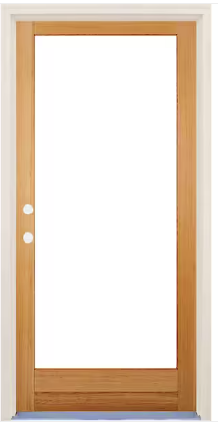

Black aluminum deck railings
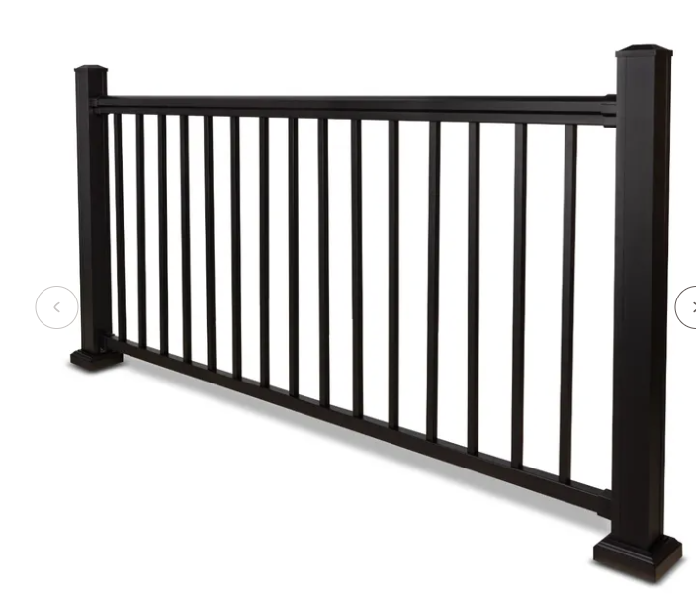
Hardie board for rear addition – Gray Cedarmill
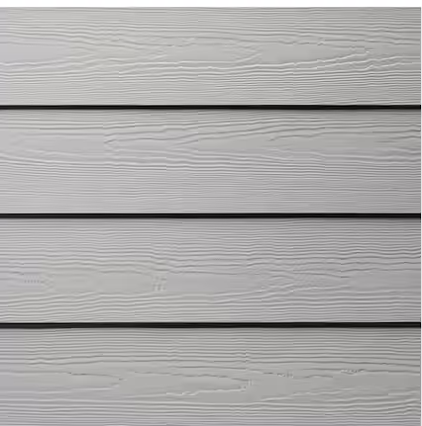

Hardie Batten Vertical siding for sides and inset (deck areas). Midnight Soot Rustic Grain.
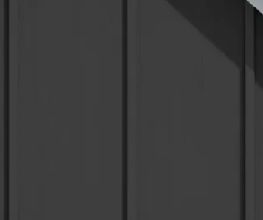
Windows
Black Vinyl – brand TPBD
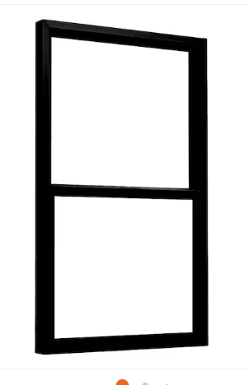

Deck Fascia - black
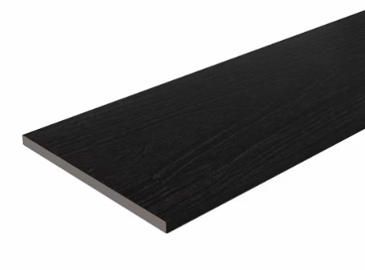

Lighting:

Flood lights for rear yard area
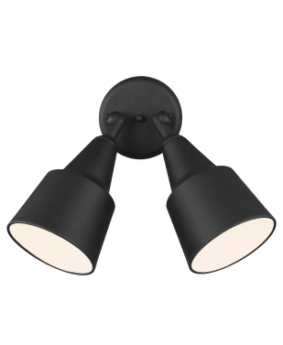


Please see proposed elevations and site plan for further detail.
Thank you,
Ian Siepel
Project Manager
Architectural Designer
NW2 Engineers

